How to log Welcome Call Notes

- Click on “Add Note” for the student you want to add a note to
  - There are many different ways to get to a student’s information and bring up the TV Note box. If you need help with this step, please find a UTVA staff member that can show you
- Type in “Weekly Contact” in the Add Tag field
- Click on the Tag button
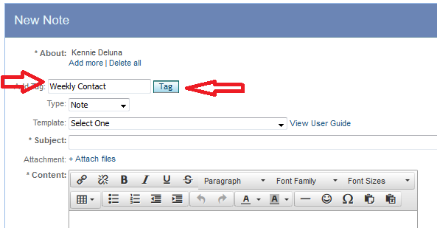
- Select “Phone Log” from the Type field
- Select “Welcome Note” from the Template field
- Leave the subject line alone. Yeah, don’t change, add, or delete anything from the subject line
  - Making changes to the subject line will cause your Welcome Call to not be counted as completed
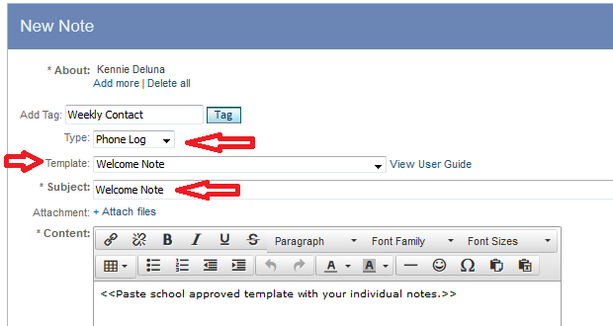

- Type your Welcome Call notes into the Body of the TV Note
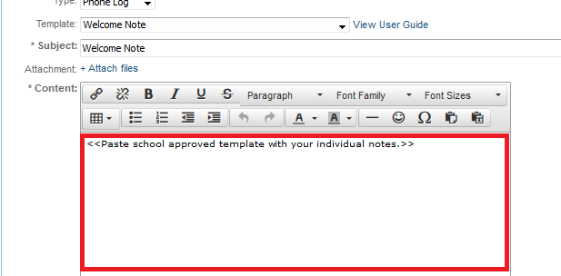
- When you are done, click on the Save button

